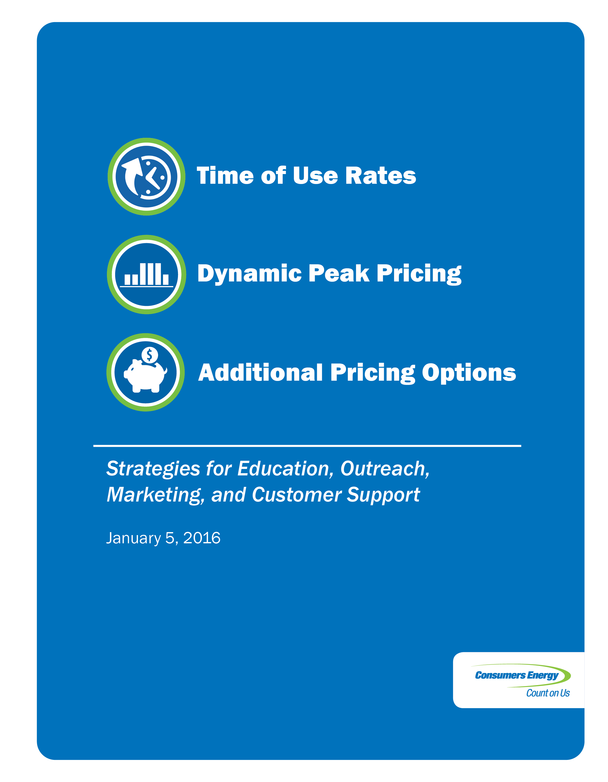

Table of Contents
A Commitment to Innovative Pricing Options 1
Rates Overview 2
Consumers Energy TOU 4
Residential Customer Rate Options 4
Non-Residential Customer Rate Options 6
Future Consumers Energy TOU Rates 9
Residential Smart Energy Pilots and Future Rate Options 9
Peak Power Savers Program 10
DPP Program 12
Additional Non-residential Rate Options and Programs 17
Education/Outreach Efforts and Customer Engagement 18
Website 18
Web Portal 18
Smart Energy Customer Engagement and Outreach 21
Additional Customer Education and Outreach Efforts 22
Energy Supply Benchmarking and Metrics 23
Energy Optimization and AMI 24
Understanding the Synergies 24
Energy Optimization & Smart Energy Pilots 25
Additional Energy Saving Options 27
Conclusion 29
Appendix A – Dynamic Peak Pricing Marketing Tactics 30

 | A Commitment to Innovative Pricing Options
On June 30, 2015, the Michigan Public Service Commission (“MPSC” or the “Commission”) issued an order in Case No. U-17688 requiring Consumers Energy Company (“Consumers Energy” or the “Company”) to file a report describing the Company’s strategies for education, outreach, marketing, and customer support of Time of Use (“TOU”) rates and other pricing options available for customers. The Commission also requested the Company’s plans on how it intends to integrate Advance Metering Infrastructure (“AMI”) with these customer programs.
Consumers Energy is committed to providing safe, affordable, and reliable energy to Michigan residents. The Company has focused efforts on improving customer satisfaction by delivering an exceptional customer experience with every interaction. This includes providing customers with information and options that enable them to make informed decisions regarding their energy use. A key component of Consumers Energy’s commitment to its customers includes offering a variety of innovative energy efficiency and load management programs along with rate options that send price signals reflecting the true cost of energy.
A cornerstone of improving the customer’s experience is the development and implementation of the Consumers Energy Smart Energy® program. This includes upgrading the electric metering infrastructure for the Company’s 1.8 million electric customers with AMI meters and the associated systems. This technology provides the opportunity to re-introduce the Company to our customers by providing timely, relevant communications, new energy options and information on future energy demands, and services customers care about. The positive response from customers shows the strengthening of this connection.
Smart Energy is a foundational, enabling technology that leverages new infrastructure in ways that allows Consumers Energy to integrate the customer’s consumption data (via the web portal) with energy efficiency opportunities and rate options. These programs support and complement each other, enabling future customer energy needs. Those needs could include programs such as TOU rates, further integration and extension of AMI/Smart Energy programs, and Dynamic Peak Pricing (“DPP”) programs. These offer opportunities for the Company to meet future capacity needs while reducing energy costs for all customers.

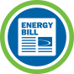 | Rates Overview
Electric prices paid by utility customers can generally be categorized into three rate types:
Flat Rate: Customers on a flat rate are billed the same rate for all use for a given time period, typically a monthly billing cycle.

Tiered Rate: Tiered rate billings are calculated using different prices dependent on blocks of energy use during a given billing cycle, charging one rate for the first block of use (i.e. 600 kWh/month) and a higher rate for the next block of use. These rate types reflect seasonal differences in energy supply costs, but do not support the engagement of customers in minimizing hour-to-hour or day-to-day energy supply costs. With this type of rate structure, high-use customers will pay more on average for energy than low-use customers.

*Customers will reach the 600kWh threshold at different points in the billing cycle.
Tariff rate structures for Consumers Energy’s Residential Service Secondary Rate (“RS”), Commercial & Industrial (“C&I”) General Service Secondary Rate (“GS”), C&I General Service Secondary Demand Rate (“GSD”), and C&I General Service Primary Rate (“GP”) are examples of flat or tiered billing rates.
TOU: TOU rate plans attempt to actively engage customers by more closely relating the customer’s price of energy with the time of day that energy is used, generally reflecting a higher cost of service when overall system electric demand is high (i.e. summer weekday afternoons) and lower cost of service when demand is lower (i.e. nights and weekends). This means when a customer uses energy can have just as much influence on a customer’s bill as how much energy they use. Customers are also provided a price incentive to shift energy use away from more expensive periods. TOU rates benefit customers by helping them save money while also reducing demand on the electric grid at peak times.

While TOU rates have been in effect for several years, the precision and adaptability of the TOU periods has been largely constrained by the limited granularity of energy use reported by traditional electric meters. Traditional electric meters, with a single data register, are limited to flat and tiered rate structures.
The AMI meters by electric utilities enhances opportunities to engage customers in new types of pricing programs that better recognize differences in the cost of power over multiple time intervals. By recording energy use in more frequent and finer intervals (i.e. one hour to 15 minutes) and providing that data to the customer (i.e. through a web portal), customers can make more informed decisions and manage their energy costs more effectively.
Time-based rate offerings include:
- TOU pricing – prices for use over broad time-specified intervals where the price for each period is predetermined and constant within each time interval.
- Critical Peak Pricing (“CPP”) – when electricity prices are forecasted to be extremely high or electric system emergency conditions are expected, the utility initiates a Critical Peak Event. During Critical Peak Events, electricity prices increase, incentivizing a shift in energy consumption to lower-demand time periods. Typically, customers are given a discounted rate during Off-Peak or non-critical times and the utility provides advance notice of the CPP period.
- Critical Peak Rebates (“CPR”) – similar to CPP, but the price for electricity used during these time periods remains the same as a normal On-Peak time interval, and the customer is incented to respond to load reduction requests by rebates that are calculated based on avoided use during the critical peak period.
Both CPP and CPR programs are referred to as DPP programs, due to their variability in when the peak pricing or rebate occurs. The following sections describe plans for enhancements to the TOU and DPP programs enabled by AMI data.
 | Consumers Energy TOU

Residential Customer Rate Options

Rate RS
Consumers Energy’s standard Residential Rate RS consists of a monthly system access charge and a volumetric charge for each kWh used, including an inverted pricing block during the summer billing months. During the summer months of June through September, the rate charges a higher amount for use over 600 kWhs. This is designed to send a price signal to customers to reduce demand associated with air conditioning, which is largely responsible for increases in summer energy load and significantly increases the Company’s capacity requirements. The vast majority of Consumers Energy’s residential customers are served on this rate, reaching more than 1.6 million customers.

Residential Service Time-of-Day Secondary Rate (“RT”)
The alternative to the standard Residential Rate RS is the Residential Rate RT consisting of a year-round rate with On-Peak and Off-Peak periods, in which On-Peak energy is more expensive. In addition, similar to the Residential RS, the RT On-Peak sets a higher price during the four summer billing months of June through September. This rate offers customers an option to shift their use to the Off-Peak period to take advantage of lower priced energy instead of lowering their overall consumption, which is the only way to avoid the higher price on Rate RS.
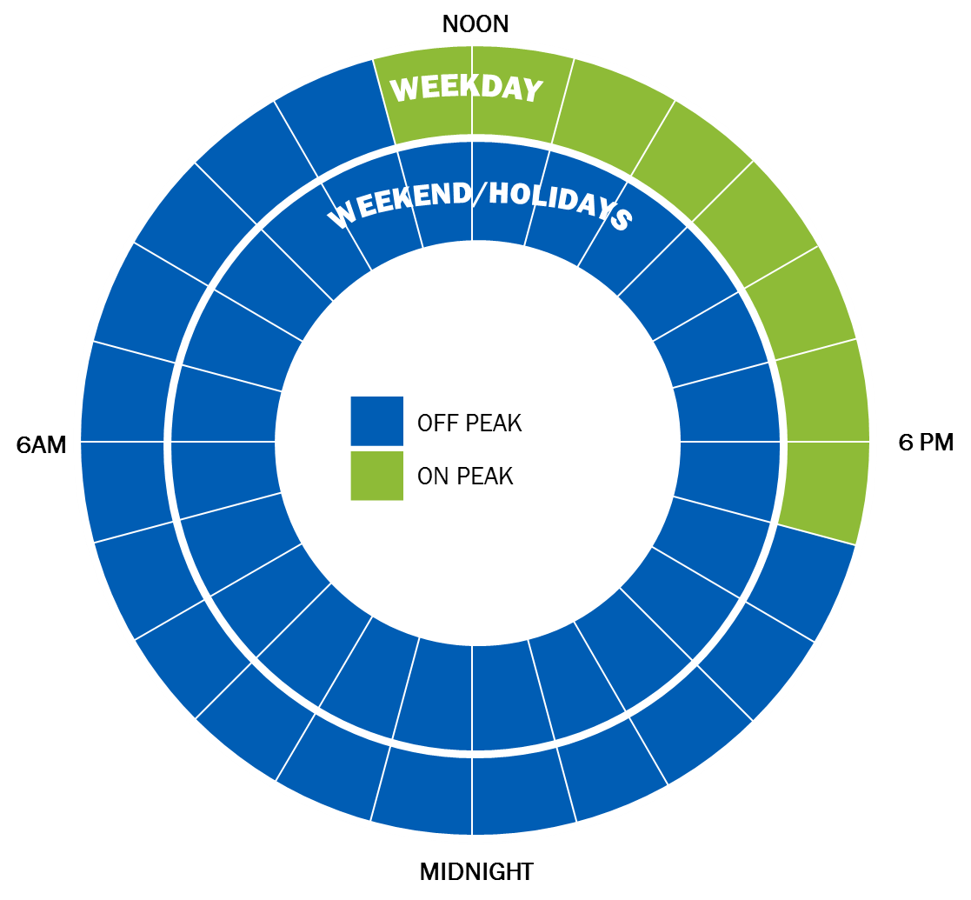

Energy consumed between 11 a.m. and 7 p.m. on weekdays is billed at the On-Peak rate. Energy consumed on weekends or between 7 p.m. and 11 a.m. on weekdays is billed at the Off-Peak rate. Over the course of a week, 76% of all hours are considered Off-Peak hours, while 24% of all hours are considered On-Peak hours.
Rate RT is currently limited to 10,000 customers by the Commission-approved tariff. Currently, there are less than 2,000 residential customers taking service on the RT rate. The Company is planning to modify the residential TOU rate in its next general electric rate case to create both high- and mid-price periods and to incorporate a CPP (or CPR) component. The modification of the TOU periods will align the rate design more closely with the Residential Dynamic Pricing provision, as well as the Residential Electric Vehicle Rate (“REV”) and the General Service Primary Time-of-Use (“GPTO”) rate time blocks. The creation of the additional summer time block will provide customers with greater flexibility in avoiding the High-Peak price and will better align the price with the cost of energy and capacity for that time period.

REV
Consumers Energy also offers TOU rates for electric vehicle charging. The Company offers two options for vehicle charging, a whole house TOU rate or a separate meter specifically for the vehicle charging.
Both rate options offer block rates based on the time of day the service is used, broken into the following time periods:
- During the winter months of October through May, the On-Peak period is Monday through Friday during the hours of 7 a.m. to 11 p.m. The Off-Peak period includes weekends, holidays designated by the Company, and Monday through Friday during the hours of 11 p.m. to 7 a.m.; and
- During the summer months of June through September, the On-Peak period is Monday through Friday during the hours of 2 p.m. to 6 p.m. The Off-Peak period includes weekends, holidays designated by the Company, and weekdays between the hours of 11 p.m. to 7 a.m. The hours of 7 a.m. to 2 p.m. and 6 p.m. to 11 p.m. are considered Mid-Peak.
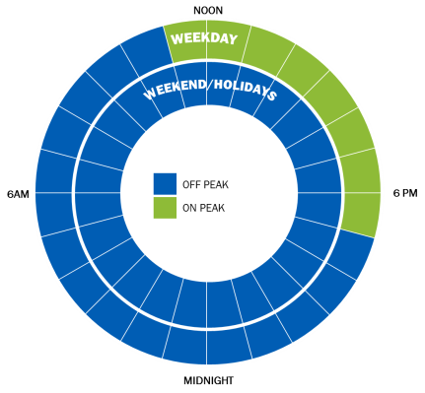  Winter Months: October - May | 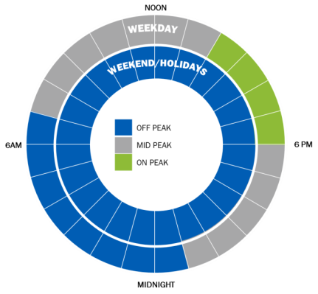  Summer Months: June - September
Electric vehicle technology and infrastructure is still developing in Michigan. During 2014, there were approximately 669 customers being served on the REV rates.

Non-Residential Customer Rate Options

Rate GS and Rate GSD

Consumers Energy offers nonresidential customers served at Secondary Voltage levels two general rate options, GS and GSD. Rate GS is a volumetric rate that charges a flat $/kWh. The rate per kWh is higher during the four summer billing months to reflect the Company’s higher power costs during that period. Rate GSD is an alternative to the volumetric GS rate and incorporates a monthly demand charge for the customers’ highest demand during the month on a $/kW basis. Generally speaking, rate GS is more economical for small nonresidential energy users, while GSD is more economic for larger users.

GS Rates - Direct Load Management (“DLM”)
Consumers Energy currently has approved tariffs offering nonresidential secondary customers a DLM pilot option under Rate GS, similar to the DLM (Peak Power Savers) developed for residential customers. Under this rate option, the Company offers customers an inverted block rate (or lower rate) for use over 1,200 kWh a month during the summer months.

GS Rates - Dynamic Pricing Pilot
Prior to implementation of AMI technology, Consumers Energy requested and received approval of tariffs offering GS and GSD customers the option to participate in a DPP pilot. Similar to the residential DPP option, this option offers customers a TOU rate during the summer billing months of June through September, along with a critical peak component that charges a higher price during Critical Peak Events. The Company is planning to develop and propose TOU rates for GS customers as noted later in this report.
GP Rates

The Company currently offers its larger nonresidential customers served at Primary Voltage levels (greater than 2,400 Volts) several rate options including GP, General Primary Demand (“GPD”), GPTU, and the Energy Intensive Primary (“EIP”) rates. Each of these are broken into three distinct rate schedules reflecting the voltage level at which the customer is connected to the Company’s distribution system, Voltage 1 (transmission), Voltage 2 (subtransmission), and Voltage 3 (primary).

Similar to the Secondary GS rate structure, Rate GP charges for energy use based on a flat per $/kWh basis, while Rate GPD incorporates demand charges similar to the Secondary GSD.

Rate GPD – Interruptible Service Provision (“GI”)
Rate GPD offers an interruptible service provision (Provision GI) that gives customers a monthly $/kW credit for the amount of load contracted on this provision. The Company has the right to request the customer interrupt their load to the level specified in the customer’s contract when the Company deems it necessary to maintain system integrity or when it has enacted emergency electrical procedures for capacity shortfall in response to a Midcontinent Independent System Operator (“MISO”) load shed directive. Currently, the Company has 62 MW of load under the GI Provision.

Rate GPTU
Consumers Energy offers a GPTU rate for primary customers who have flexibility to shift energy use to Off-Peak, lower-price periods. Rate GPTU has a High-Peak period of three hours and was introduced in July 2013 with a total program size of 100 MW of Demand Capacity. Customers on Rate GPTU pay a system access charge, consumption-based energy charges, and Maximum Demand capacity charges. The rate does not have On-Peak capacity charges.
Rate GPTU is broken into the following time periods:
- During the winter months of October through May, there are three time periods. The High-Peak period is Monday through Friday during the hours of 4 p.m. to 7 p.m. The Mid-Peak period is Monday through Friday during the hours 2 p.m. to 4 p.m. and 7 p.m. to 9 p.m. The Off-Peak period includes weekends, holidays designated by the Company, and Monday through Friday during the hours of midnight to 2 p.m. and 9 p.m. to midnight; and
- During the summer months of June through September, there are four time periods. The High-Peak period is Monday through Friday during the hours of 2 p.m. to 5 p.m. The Low-Peak period is Monday through Friday during the hours of 6 a.m. to noon and 7 p.m. to 11 p.m. The Mid-Peak period is Monday through Friday during the hours of noon to 2 p.m. and 5 p.m. to 7 p.m. The Off-Peak period is not changing and continues to include weekends, holidays designated by the Company, and weekdays between the hours of midnight to 6 a.m. and 11 p.m. to midnight.
Winter Months: October - May | Summer Months: June - September
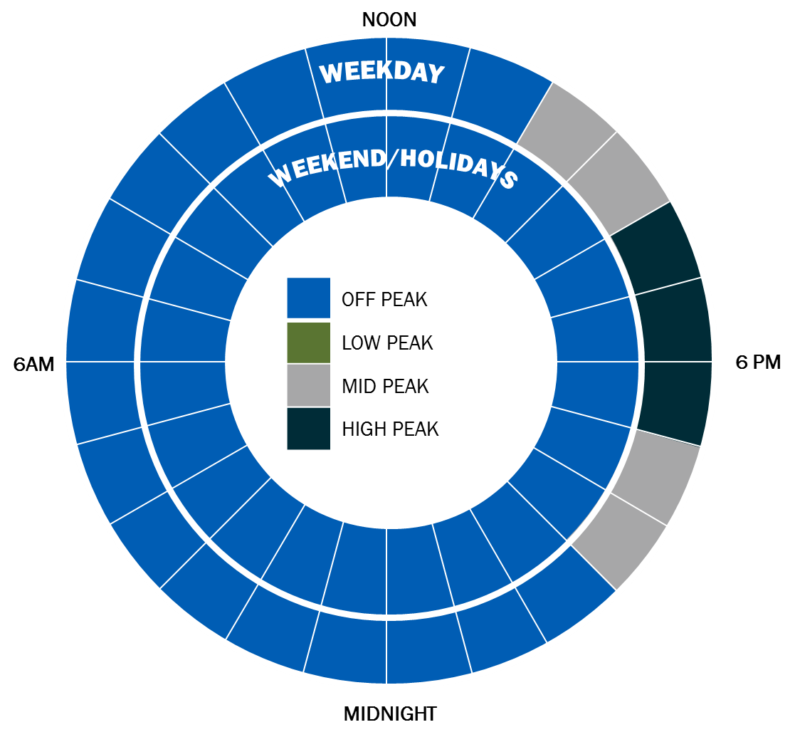 | 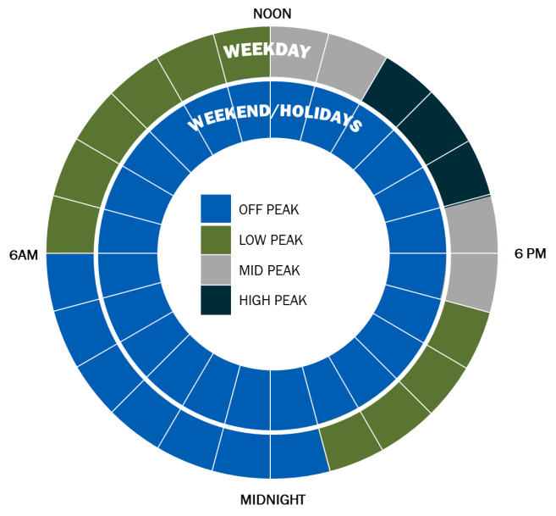
The GPTU rate was fully subscribed by the end of 2013, when the initial program limit was established at 50 MW of load and a waitlist was developed by the Company for those customers who expressed an interest. On November 19, 2015, the Commission approved Consumers Energy’s proposal to double the size of Rate GPTU to 100 MW of Maximum Demand. The expanded rate offering became effective on December 1, 2015 and the Company’s Business Customer Experience organization is notifying customers on the wait list of its expanded availability.

Metal Melting Primary Pilot Rate (“MMPP”)/EIP Rate
Consumers Energy initially developed the MMPP rate for EIP customers who utilize electric load for industrial metal melting processes. The MMPP rate is essentially a TOU rate that allows the Company to call Critical Peak Events signaling the market price has exceeded an Economic Trigger Price or that a system integrity event is occurring. The rate was introduced in June 2012 and was open to all customers taking service under the metal melting provision at that time. Additional capacity of 50 MW of Maximum Demand was made available to new electric metal melting load in 2013 with the Commission’s rate order in the Company’s electric rate Case No. U-17087. Customers on rate MMPP pay a system access charge, consumption-based energy charges, and a Maximum Demand capacity charge. The rate does not have On-Peak capacity charges.
Rate MMPP is broken into the following time periods:
- During the winter months of October through May, there are three time periods. The High-Peak period is Monday through Friday during the hours of 5 p.m. to 7 p.m. The Mid-Peak period is Monday through Friday during the hours 4 p.m. to 5 p.m. and 7 p.m. to 8 p.m. The Off-Peak period includes weekends, holidays designated by the Company, and Monday through Friday during the hours of midnight to 4 p.m. and 8 p.m. to midnight; and
- During the summer months of June through September, there are four time periods. The High-Peak period is Monday through Friday during the hours of 3 p.m. to 5 p.m. The Low-Peak period is Monday through Friday during the hours of 6 a.m. to 2 p.m. and 6 p.m. to 11 p.m. The Mid-Peak period is Monday through Friday during the hours of 2 p.m. to 3 p.m. and 5 p.m. to 6 p.m. The Off-Peak period includes weekends, holidays designated by the Company, and weekdays between the hours of midnight to 6 a.m. and 11 p.m. to midnight.
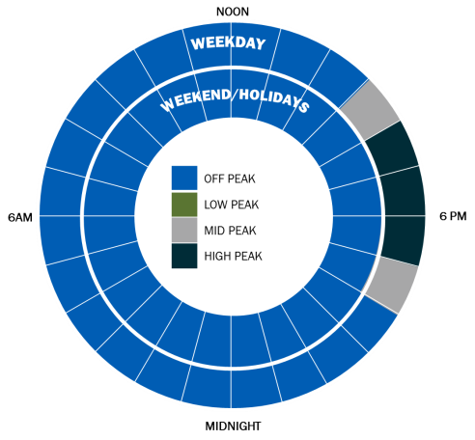  Winter Months: October - May | 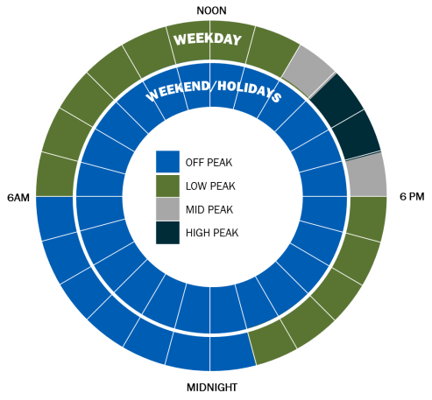  Summer Months: June - September
The Commission approved several changes to Rate MMPP in Case No. U-17735 in its rate order on November 19, 2015. These changes included modifying the name of the Rate MMPP to EIP Rate and increasing the rate availability to 200 MW of Maximum Demand capacity to customers with new electric metal melting or new energy intensive industrial load. To qualify, the new energy intensive load must exceed 2 MW per site and have an annual load factor that exceeds 70%. These modifications became effective December 1, 2015.
 | Future Consumers Energy TOU Rates
As the Company upgrades metering technology and associated systems from traditional electric meters to AMI meters, rate and program options are transitioning to provide the greatest customer benefit and value, regardless of metering technology. Below are planned modifications to rates that do not require an AMI meter.
- Rate RT: The Company is planning to modify the residential TOU rate in its next general electric rate case to create both high- and mid-price periods and to incorporate a critical peak price (or rebate) component. The modification of the TOU periods will align the rate design more closely with the Residential Dynamic Pricing provision, as well as the REV Rate and the GPTU rate time blocks. The creation of the additional summer time block will provide customers with greater flexibility in avoiding the High-Peak price and will better align the price with the cost of energy and capacity for that time period.
- GS Rates - DLM: The Company plans to modify this rate in its next general rate case so it provides customers with a capacity credit on a $/kW basis, so the incentives are equitable to all participants across various rate schedules and customers are rewarded based on their actual performance.
- GS Rates - Dynamic Pricing Pilot: The Company is planning to develop and propose TOU rates for GS customers. The proposal will either be through the Company’s next general electric rate case or through a separate filing if necessary, depending on timing so rates can be made available by January 2017. Critical peak dynamic pricing components will be added to secondary TOU rates when the system work required to support the necessary communications to nonresidential customers is implemented.

Residential Smart Energy Pilots and Future Rate Options
Consumers Energy first conducted residential pilot programs in 2010 with the Peak Power Savers and Personal Power Plan to evaluate customer response and load reduction potential for different demand response treatments. Below is a short description of each pilot:
- Peak Power Savers was a dispatchable demand response program. Customers were recruited, using direct mail marketing, and offered a $25 incentive and 8.43% rate reduction on energy charges over 600 kWh per summer month. Over 2,200 residential customers participated in this pilot, all in the Grand Rapids area, and had load control switches installed on their air conditioning units. While participating customers did not receive advanced notification of the cycling events, many customers were not aware of when the events occurred, according to focus groups and surveyed participants. Post pilot surveys showed a high overall satisfaction at 83% with 92% expressing interest in participating in the same program again. Post pilot data analysis showed an average participant load reduction of 1.01kW at an outdoor temperature of 90º F.
- Personal Power Plan was a non-controllable, non-dispatchable demand response program. This pilot evaluated participants’ response to technology, new types of information and dynamic rate structures. The DPP pilot was conducted in the greater Jackson area and included providing customers with pricing information via web portal access and e-mail notifications, technology in the form of an intelligent, communicating thermostat and dynamic rates based on CPP information. Customers were recruited using direct mail marketing and outbound calls by the implementation vendor. The number of customers enrolled exceeded the initial target by 10%. Customers received a day-ahead notification for Critical Peak Events, via their preferred method (SMS Text message, e-mail, automated phone call). When a Critical Peak Event was declared, DPP customers positively responded to, and derived benefit from, the pricing signals sent by the Company.
Building on the success of these pilots and incorporating additional industry learnings, such as the need for robust customer education and marketing plans, Consumers Energy is launching the following Smart Energy enabled programs.

Peak Power Savers Program
Peak Power Savers will be offered to customers with a smart meter in 2016, as our residential Direct Load Control (“DLC”) air conditioning program. This program can be used to reduce load on peak demand days, decreasing the need for purchase or construction of peak generation capacity. In exchange for participation in the program, customers are given bill credits through the summer season of June through September. The credits will be applied directly to their energy bill. The load control peak demand reduction will be achieved using the AMI infrastructure including ZigBee smart meter technology. A signal from the Company’s Demand Response Management System (“DRMS”) activates and manages the timing of central air conditioning equipment cycling during a peak demand period.
Customers will receive a one-time $25 sign-up incentive to participate in the program in addition to a discounted rate for use greater than 600 kWh during the months of June through September. The rate applies to summer use annually while the incentive is only offered for initial sign-up. Most participating customers in similar programs experience no discomfort as a result of these types of programs, and participation and life of the technology both tend to be very long.
Direct load reduction of central air-conditioning units is used broadly across North America to reduce peak demand. The United States Federal Energy Regulatory Commission (“FERC”) has identified more than 300 residential DLC programs being offered around the country, with more than 5 million total participants. For example, Xcel Energy has 600,000 participating customers and DTE Energy has 280,000 customers. The Consumers Energy Peak Power Savers program will enroll 110,000 customers over the next four years, avoiding over 121 MW of additional capacity purchases. Survey results indicating customer participation interest are provided below.
New pricing options will require strong marketing to build awareness, plus customer education to communicate the benefits of cost and energy savings. To achieve these goals, Consumers Energy has selected an experienced marketing service provider to administer the Company’s marketing plan for education and enrollment in Peak Power Savers. The marketing service provider’s strategy for this program includes a combination of tactics shown in the chart below and described in further detail. The plan includes:
- Advanced market segmentation using predictive data analytics and reporting to drive marketing strategy across all program years;
- Customer awareness outreach such as earned media, customer communications, social media, program website, and community outreach;
- Post AMI meter installation brochures to be left behind by meter installation technicians to capitalize on high customer awareness of the smart meter program and customer motivation to benefit from their new smart meter to reduce energy consumption and save money;
- Scalable direct marketing campaigns including targeted direct mail, email, and outbound telemarketing to actively recruit participants according to planned program production goals and boost or limit enrollments as needed; and
- Participant communication materials to ensure participants understand how the program works and know how to contact the program team if they have any questions.
Customer Recruitment Tactics | 2016 | 2017 | 2018 | 2019
Market Segmentation & Data Analysis | X | X | X | X
Post Meter Install Recruitment Brochure | X | X
Micro Website | X | X | X | X
Earned Media Outreach | X | X | X | X
Social Media Outreach | X | X | X | X
Consumers Energy Customer Channels | X | X | X | X
Community Outreach | X | X | X | X
Targeted Direct Mail Campaigns | X | X | X | X
Targeted Email Campaigns | X | X | X | X
Targeted Outbound Telemarketing |  |  | X | X
Scalable Direct Marketing Tactics
- Targeted Direct Mail Campaigns will be targeted to customers identified as likely to have central air conditioning and participate in load control programs based on the marketing service provider’s predictive modeling. Direct mail testing will be an integral part of the plan to ensure optimal results and learnings over time. The marketing service provider will manage the entire direct mail process - from selecting the target data sets and preparing the mail pieces to releasing the mail batches in accordance with the planned operations. The mail pieces will include a well-defined offer and a call to action. The marketing service provider will develop a direct mail letter to be used in the first year of the program. This direct mail piece will form the foundation for future testing of other direct mail creative designs. In addition, direct mail pieces will be adjusted seasonally as needed.
- Targeted Email Campaigns provide a cost-effective tactic for recruiting participants for load control programs. The marketing service provider will leverage customer email addresses provided by the Company and will purchase additional email addresses if necessary. Email campaigns will be sent in waves and will include provision for opt-out requests.
- Outbound Telemarketing will be used during the last two years of the program recruitment when market penetration levels are anticipated to exceed 10%. The marketing service provider plans to incorporate outbound telemarketing into the plan along with increased direct mail volume. The outbound telemarketing effort will be coordinated to follow direct mail drops by one to two weeks to ensure optimal results.

Peak Power Savers Program Success Metrics
The following metrics will be monitored at the program level as key determinants of program success:
- The enrollment target is 110,000 customers through 2020. Customer acquisition will equal 15% of customers with central air-conditioning units or 6% of all customers. These enrollment goals are achievable based on our analysis of similar programs across the industry.
- Per-customer reduction in Peak Power Savers is expected to be 1.1 kW on average. This reduction will be measured through AMI meter data through the DRMS that Consumers Energy implemented in 2015.

DPP Program
Similar to Peak Power Savers, the DPP plan is designed to leverage AMI technology to provide residential customers with new pricing options. Customers are incented to reduce energy use during high-cost periods of peak demand on the grid, which helps to:
- Save customers money when they shift consumption from high-demand, high-cost weekday time periods to low-demand, low-cost weekday time periods and all hours on weekends; while
- Assist the utility in enhancing grid efficiency, reliability and improving environmental sustainability by mitigating the need to accommodate large variations in electric demand, and reducing required peak generating capacity and/or energy purchases.
To achieve this, the plan offers alternatives to the traditional tiered, per kWh flat rates with TOU based rates which offer low prices during low-demand times and higher prices during times of peak demand. Importantly, during periods of extremely high demand, typically the hottest days of summer when air-conditioning load is highest, customers will be notified by email one day in advance of Critical Peak Events, with additional options for notifications by text and/or automated phone call. These events provide customers with significantly stronger incentives to reduce their On-Peak use by increasing their thermostat’s set-point or by waiting to run major appliances at other times.
Time-of-Use Based Pricing
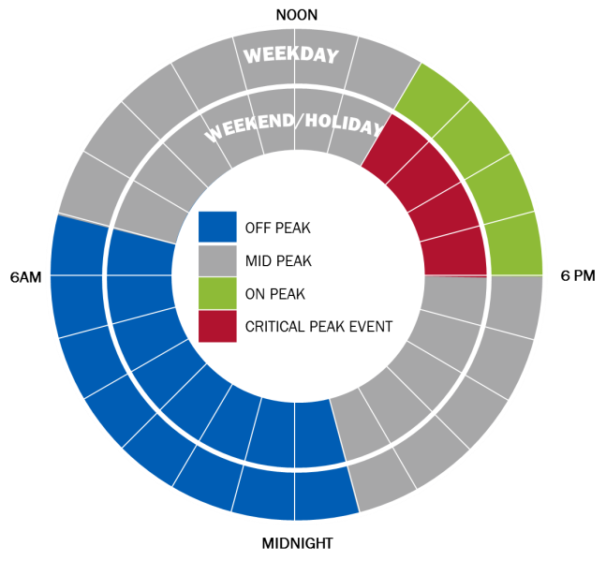
*all weekend hours are off peak
The DPP plan offers two separate pricing options with different rates and structure of incentives for customers. These options are described below:
- CPP: On critical peak days, the price of On-Peak use increases dramatically. However, this is offset by providing the lowest available rates on non-critical peak times. This option offers the highest potential savings for customers who reduce their On-Peak and critical peak use.

- Peak Time Rebate (“PTR”): On critical peak days, the customer’s On-Peak energy use is billed at the standard On-Peak rate. However, their use is compared with their average use for the same time period on the five previous, non-critical peak business days to determine the amount use was reduced during the Critical Peak Event, if any. The customer then receives a rebate based on the amount of this reduction. This option offers customers a way to experience the benefits of DPP without risking High-Peak time charges, but offers slightly less savings potential than CPP for this reason.
A table summarizing the rates associated with each of these pricing options is below:
 | DPP Rate Option
 | CPP | PTR | Time of Day in Effect
Off-Peak | $ 0.060257 | $ 0.072133 | Midnight to 7 a.m. and 11 p.m. to midnight weekdays and all weekends
Mid-Peak | $ 0.094533 | $ 0.113165 | 7 a.m. to 2 p.m. and 6 p.m. to 11 p.m.
On-Peak | $ 0.119517 | $ 0.143073 | 2 p.m. to 6 p.m.
Critical Peak Pricing (or Rebate) | $ 0.950000 | $ (0.950000) | 2 p.m.to 6 p.m. during a Critical Peak Event day
All charges are per kWh use. Rebate is based on kWh reduction from baseline.
Rates were approved in the November 19, 2015 Order in Case No. U-17735
The rates stated above are active for a customer during the summer months only, from June through September. During all other months the customer returns to the traditional residential rates.
Below are graphical representations comparing rates offered through CPP and PTR with the traditional, tiered rates shown on the graphs with dashed red lines. The lower line represents the rate for the first 600 kWh a customer uses monthly, while the upper line represents the price for all monthly use over 600 kWh.

CPP offers significant savings potential for customers, with On-Peak rates which are still below traditional flat rates for use greater than 600 kWh. The Critical Peak Event rate is significantly higher than all other rates, sending a strong price signal to customers to reduce use during these events.
Below is an image of the PTR’s rate structure during non-event days. These rates are slightly higher than for CPP, offering less of a savings potential. It is important to remember that during Critical Peak Events PTR customers are still charged $0.143073/kWh, so there is also less risk of receiving high charges during these events. For each kWh of use reduced from the customer’s baseline, they will receive a credit back of $0.95.

This program will be made available to residential AMI customers by January 1, 2017. Similar to Peak Power Savers, a third party will implement the program marketing and customer education plan. But unlike Peak Power Savers, no site visits or device installation is required. The education and enrollment of customers to the rate that is the best fit is critical to customer satisfaction and program success. The key elements to successful implementation are:
- Rate Comparisons. Easy to use and accurate rate comparison tools that allow customers to evaluate the value of the program. This program will leverage the rate comparison tools provided by the vendor as part of the interval web portal.
- Education. Education about how energy intensive activities can be shifted to Off-Peak periods. This includes providing estimates or education about how much energy these activities consume.
- Event Call Handling. During peak events, call center representatives will be available to help customers understand what they can do to reduce their consumption. This will be available from the Company’s call center or the third party call center.
- Successful marketing. Program marketing will be managed by a third party. A strong and successful marketing campaign, detailed below, includes:
  - Education about peak energy periods;
  - Tips on ways to shift energy consumption to Off-Peak periods;
  - Tips on how to reduce energy consumption on critical peak days; and
  - Rate information and potential savings amounts.
- Easy Enrollment. The enrollment process must be simple to ensure maximum participation.
Because marketing for the DPP Program will not begin until 2017, plans are still under development. The efforts will begin with testing a variety of marketing channels and messages, identifying the most effective of each to improve future marketing success and for a broad expansion in marketing efforts based on those learnings in 2018 and beyond.
Marketing materials will provide customer education emphasizing the impact of voluntary reduction of peak demand to electricity costs and reliability. Analysis of previous program results showed customers appreciated knowing how they were able to contribute, so contact detailing event days and as a thank you will be considered.
Key elements of the marketing strategy include:
- Customer marketing through the Consumers Energy website, bill insert newsletter, and e-mail blasts;
- Press releases;
- Mass media advertising including print, digital or radio options; and
- Cross promotional opportunities with other Smart Energy efficiency programs, such as energy star appliance, appliance recycling, or heating and cooling programs which provide customers with ways to maximize their benefit from the DPP with opportunities for more energy efficient appliance use during peak times.
A more detailed overview of the marketing tactics is provided in Appendix A.

Dynamic Pricing Program Success Metrics
The following metrics will be monitored at the program level as key determinants of program success:
- Per customer acquisition cost (target of $50 or less per customer): This measure provides an aggregate view of the cost effectiveness of marketing activities as well as a comparison against the value of peak capacity savings on a per-customer basis; and
- Per customer reduction in critical peak energy use vs. control group (target of 0.63 kw per customer or an approximately 25% peak demand reduction): This measure provides an aggressive goal for peak savings per customer that would place Consumers Energy among the best-in-class programs of this kind, as measured by reduction per customer, shown on the chart below. While achieving this target would not be critical to the cost effectiveness of the program, an aggressive goal provides strong motivation for Consumers Energy to develop innovative ways of educating and empowering customers to maximize their energy savings during events.
Peak Reduction Results of Time-Varying Pricing Pilots
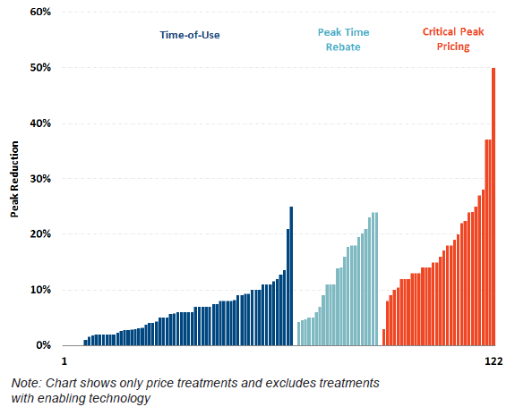
Source: Brattle Group

Customer Enrollment Call Center for Peak Power Savers and Dynamic Pricing Programs
A single customer enrollment call center will support both the Peak Power Savers program and the Dynamic Pricing programs. The implementation vendor will provide these services, including a dedicated toll-free number, answering general inquiries, enrolling customers, and resolving customer complaints. This call center will field and process the majority of customer enrollment requests with the ability to send and receive warm transfers to Consumers Energy’s call center for customers with billing, service, and other non-program related questions. However, customers will also be able to enroll via a Company Customer Service Representative (“CSR”), without the need to transfer the call. This call center will be available 9 a.m. to 7 p.m. (Monday-Friday), with Spanish language capabilities.
In addition to customer satisfaction surveys, the following customer satisfaction metrics will be evaluated monthly:
- ASA < 20 sec;
- Service Level 80%;
- Customer Survey Net Promoter Score > 8.8;
- Abandon rate <3%.

Additional Non-residential Rate Options and Programs
In 2015, the Company conducted a C&I Demand Response Pilot involving customers of various sizes, across multiple segments. Based on the results of this pilot, the Company will offer a C&I Demand Response Program starting in 2016. This demand response program provides an additional energy resource that can be used as a Load Modifying Resource to MISO for grid emergencies and during times of peak electricity demand to reduce supply costs that directly impact all of the Company’s customers via the Power Supply Cost Recovery (“PSCR”) factor. Each business customer is contracted for a specified (kW) load reduction with individualized demand reduction plans at their facility that will be implemented when a demand response event is called, (i.e., a time when electricity demand and cost are highest). When an event is scheduled, customers are notified ahead of the event, informing them of when they need to shed load. During the event, customers implement their established energy reduction plan. This engagement with Michigan businesses will deliver capacity that is scalable, ‘green’ and flexible, producing a Michigan-first, flexible energy resource from businesses that can help meet capacity needs.
Because of the variability of customers’ requirements, management and coordination will be more individualized than the residential programs. Customer assigned Account Managers and the third party demand response service provider will market this program utilizing direct contacts and existing relationships. Additional marketing will be conducted through various channels to priority customer segments that will benefit from and provide an economic and predictable demand response resource. In addition to receiving a credit based on their demand and energy reduction, participating customers have real-time access to detailed electric use information. Customers participating in the pilot found this immediate feedback most valuable to understand operational impacts on their energy use, both during and outside scheduled demand response events. In addition, the Company will apply our energy expertise and build upon this technology platform to offer a Virtual Energy Engineer Service assisting customers in realizing sustained energy use reductions and cost savings.
 | Education/Outreach Efforts and Customer Engagement

Website
Our website will be used to educate and make it easy to compare and select options. Recently, the Company redesigned our website based on customer preferences and industry best practices. The new website design has a responsive interface meaning regardless of how you view the website (computer, tablet, phone) it will automatically adjust to your device to provide a great user experience. We will also identify which service options are most popular and what type of customers may benefit the most from participating. Our new online capabilities may eventually use customer information such as type of energy service, past engagement decisions (e.g. participation in Energy Efficiency programs), profile of energy use, segmentation/personas, and other characteristics to identify possible customer interests. These options may also be promoted specifically when users are performing activities such as paying their bill, viewing energy use history, etc. where they may be most receptive to learning/comparing choices that may provide more value.
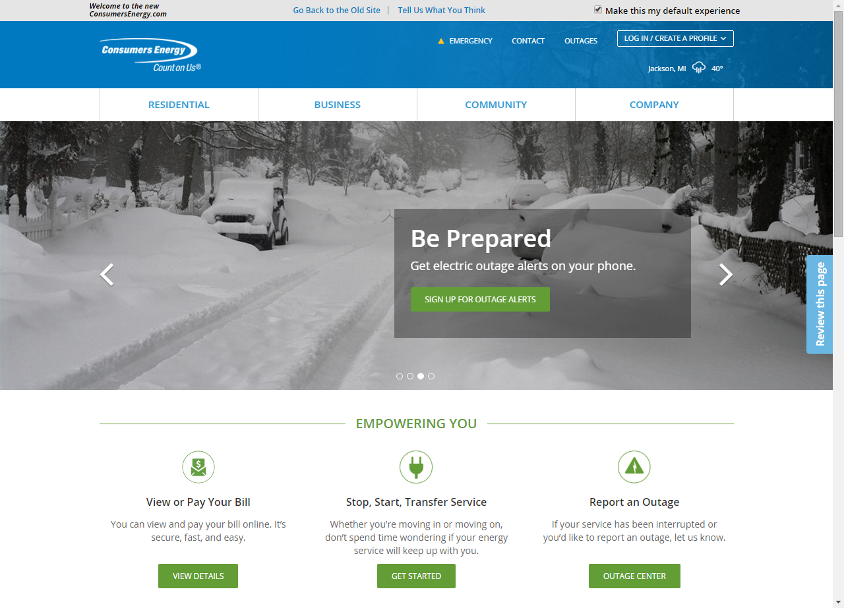

Web Portal
The web portal is designed to produce long-term electric and gas energy use reduction through residential and business customer online enabled behavior changes. This reduction is achieved by providing residential customers the ability to review their energy consumption by day (hourly), bill (daily), or annually (monthly). Business customers will have the ability to review their energy consumption by day (15 minute), bill (daily), or annually (monthly). These customers will have access to advanced online tools that will provide normative comparisons on energy consumption behaviors and energy saving tips and strategies.

Advanced Online Tools
Advanced online tools will allow customers to understand their energy use behaviors at different time intervals during the month. Energy efficiency tips will also be provided to customers for reducing energy use during those specific time periods.
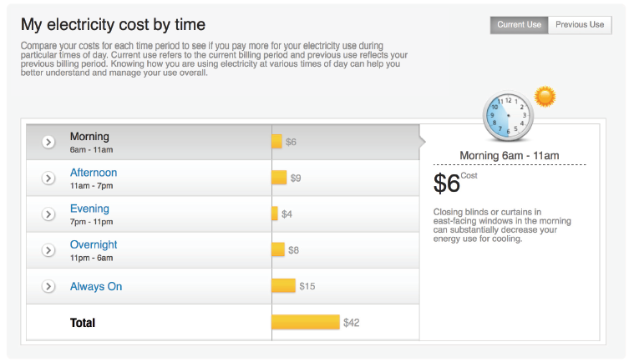
The rate plan comparison tool provides insights into dollar savings by providing alternative rate plan options to customers. Customers can then utilize this tool to gain further insights on how reducing use or shifting use for different rate plans impacts their annual dollar savings.
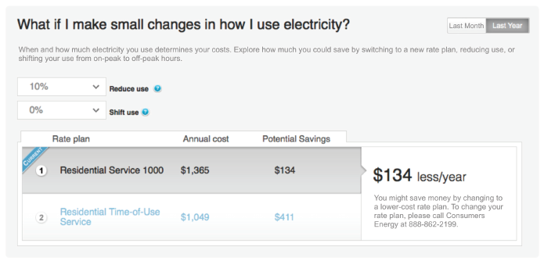
TOU rates will utilize a graphical representation for customers to better understand how their rates are structured and impacted by summer and winter season.
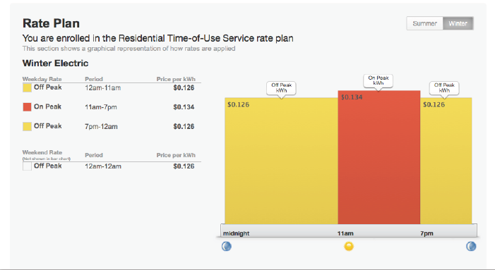
The interval web portal is organized around two concepts. First, motivate customers to change their energy use behavior by putting their use in context. Second, provide them with relevant personalized advice to capitalize on this motivation to use less energy and save money. Customers receive personalized targeted savings tips based on their energy use patterns, housing characteristics and demographics.
All marketing materials will carry two strong consumer messages emphasizing taking control of your energy use or ease of use.
Key elements of the marketing strategy include:
- Direct mail;
- Customer marketing through the Consumers Energy Web site, bill insert, social media and email blasts;
- Press releases;
- Mass media advertising including print and channels such as online or radio options; and
- Cross promotional opportunities with other energy efficiency programs.

Web Portal Use Success Metrics
The interval web portal will have metrics for participation and energy savings.
Energy savings associated by the Smart Energy Interval Web Portal is evaluated by a difference-in-differences model between treatment and control groups

Calculated using D-in-D Fixed Effects and Post Only models:
  - Consistent with Energy Optimization Collaborative decision related to Home Energy Reports;
  - Where both models produce results with similar levels of precision, use the most conservative result to report savings;
  - Dependent variable is average daily consumption; and
  - Independent variables: weather, customer fixed effects, month-by-year fixed effects, and receiving encouragement.
The Smart Energy Interval Web Portal pilot launched on July 5, 2013 and has run continuously through September 30, 2015 for residential customers. Since the interval web portal launch, Consumers Energy has had 30,846 unique web visitors that have come to the website with more than 109,000 web visits for Smart Meter enabled customers.
The Company has been working with an evaluation, measurement, and validation vendor to determine energy savings associated with the Smart Energy Interval Web Portal utilizing the difference in difference model. Our savings have ranged from 0.9% to 1.1% for customers who have engaged.

Smart Energy Customer Engagement and Outreach
Consumers Energy is using Smart Energy and the upgrading of electric meters as the opportunity to reintroduce ourselves to our customers. In 2011, we developed the Smart Grid Customer Education and Engagement Vision, outlining a phased approach to delivering customer value. Building on that roadmap, we have leveraged many tools to increase customer engagement.
Since the Company began installing smart meters in 2012, customer satisfaction has continued to steadily rise, as showcased by pre- and post-install surveys conducted in installation areas. The rise can be attributed to the phased approach, referenced above and outlined below. In addition, the variety of communication mediums used to engage customers has attributed to communication recall rates that average at 79% across installation territories. These recall rates directly correlate to the rise in satisfaction. By providing customers with the ability to engage with Consumers Energy through mediums of their choice, the Company is able to educate and inform effectively. These communications lay the foundational relationship needed to continue engagement with customers as the Company promotes TOU rates and the variety of programs enabled by the smart meter.
Our Road to Engaged Customers:
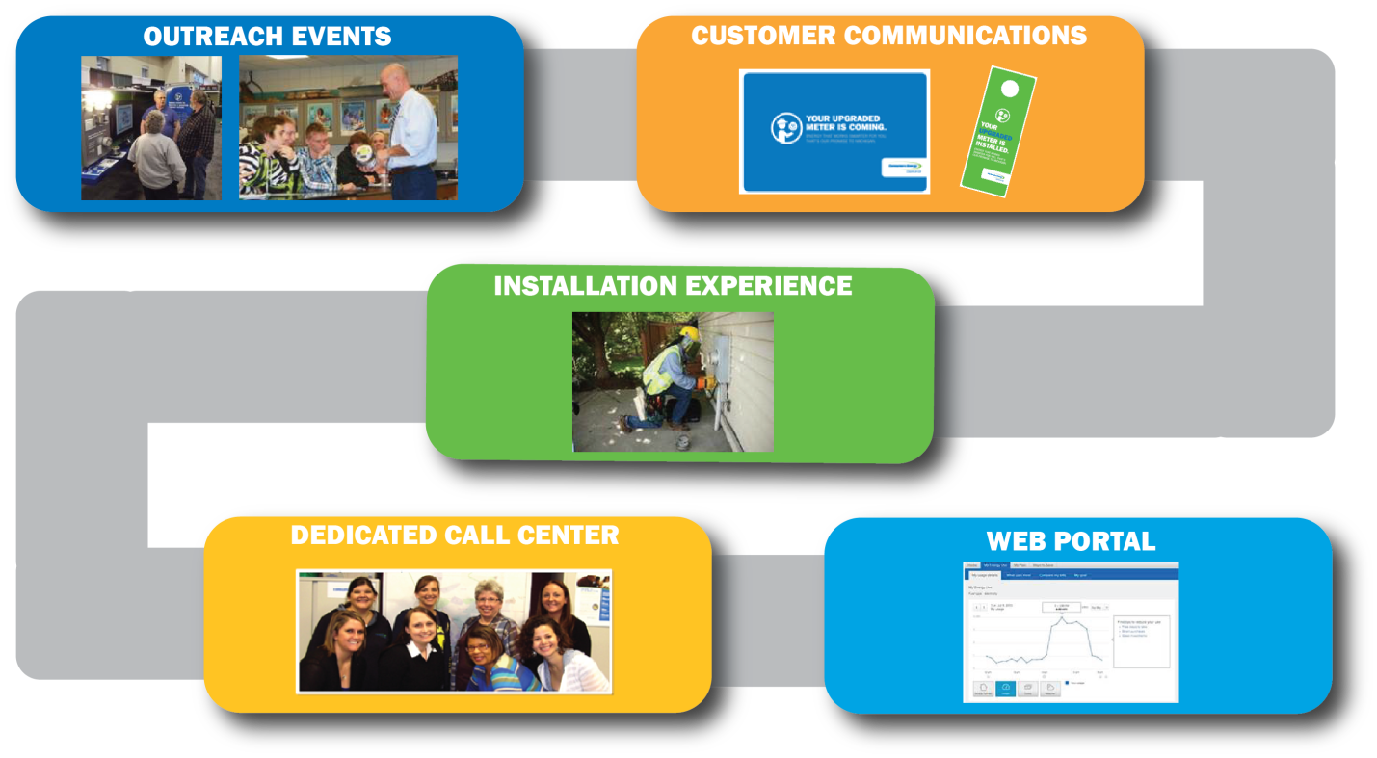
Prior to upgrading meters in a given geographical area, customers are surveyed to gain a better understanding of customers’ perceptions of smart meters. As part of these surveys, customers are asked to rate their interest in participation in Direct Load Control (“DLC”) and DPP programs (based on a short description of the program only). Customers who identified as ‘probably would’ or ‘definitely would’ participate in these programs are summarized below:
Area Surveyed | DLC | DPP
Zeeland | 34% | 34%
Grand Rapids | 56% | 45%
Kalamazoo | N/A | 45%
Flint | N/A | 45%

Additional Customer Education and Outreach Efforts
In addition to the residential customer outreach outlined above, there are a variety of different tactics that have been employed to communicate with business customers. The largest C&I customers have a 1:1 relationship with dedicated account managers. These account managers meet regularly with their clients and use these meetings as a time to promote different rate options and programs, listen to concerns, and discuss Consumers Energy offerings. Furthermore, Consumers Energy employs a robust business customer outreach strategy that includes promotions, sponsorships, and speaking engagements at various business events and a robust online campaign made up of regular emails/newsletters, a dynamic website dedicated to business-specific content, and specific two-way communications with businesses. These tactics have proven to be successful in communicating with our business customers and will continue to be utilized for continued and future engagement for all applicable products, services, and information.
 | Energy Supply Benchmarking and Metrics
In addition to program specific metrics, customer engagement and capacity secured will be measured at an overall, portfolio-wide basis.
Consumers Energy’s Energy Supply Department is responsible for securing the necessary capacity plus reserves to provide for our customers’ needs. We secure that capacity and reserve margin from a variety of sources, including traditional power plants, renewable energy supplies, the MISO market, and demand response programs. Beginning in 2016, Consumers Energy will launch the Peak Power Savers program, and the impact is measured in MW of capacity saved or displaced. A MW of load reduction at the time of the summer reduced generation requirements, and the demand response load reduction doesn’t require transmission to get from the power source to the customer, making this load reduction a very economical and effective peak load shaving tool. Consumers Energy’s 2016 Residential Peak Power Savers program is expected to achieve 15% participation among our residential electric customers and 110,190 customers by 2022. Each residential DLA customer is expected to realize a 1.1 kW peak load savings, collectively contributing capacity savings of 121 MW by 2022.
In 2015, Consumers Energy had 61.6 MW of interruptible load served under Rate GPD, Provision GI. The Company has contracts with some large C&I customers who have agreed to reduce load when directed to do so in exchange for a rate that does not have the typical capacity component. If MISO declares an electrical-system emergency, the Company contacts the customers on the interruptible rate and directs them to reduce load to the level specified in our contract for interruptible service with the customer. If an emergency event is called, the customer is notified, and then load reductions are verified by comparing the meter reads after the event to the customer’s calculated baseline load before the event. This was discussed in greater detail earlier in this report.
On March 1 of each year, the Company registers its Demand Response programs with MISO for the upcoming June 1–May 31 Planning Year. MISO requires Consumers Energy and all other Load Serving Entities (“LSEs”) to register the amount of demand response available during hours 15–17 in July and August, the time of MISO’s expected annual summer peak. The Company then receives capacity credit for these MW, saving our customers the expense of purchasing those MW on the market or building capacity to serve it.
In the event that MISO declares an electrical capacity emergency, there are a number of steps the Company takes with regard to its generation and transmission resources, such as ordering all available plants to full power, postponing or suspending plant or transmission system maintenance, and so on. Prior to shedding firm load, the Company will deploy the interruptible load we have under contract and any MW available from the Peak Power Savers program and the DPP Program. After the emergency event has concluded, we can calculate how much load was saved by our customers.
Measurement and verification of load reductions is a critical step in managing demand resources. MISO is specific in how the calculations should be performed, and this logic is functionality embedded in systems so Consumers Energy is fully compliant. After system-wide smart meter deployment, the DRMS will collect the meter reads of all customers on the program for the time period of the demand response event. The DRMS system will look retroactively from the day of the event and select the first five non-weekend, non-event days, continuing backward as far as ten days if necessary, averaging the first five selected days to yield one load shape. This customer baseline is then compared to the customer’s actual use the day of the event, and the difference is calculated, and is repeated for each customer. The result is the amount of load reduced. This value is reported to MISO via the MISO portal.
 | Energy Optimization and AMI
Since 2009, Consumers Energy’s Energy Optimization Program has helped Michigan families and businesses reduce energy consumption and system demand by over 5,800,000 MWh and 325 MWs, respectively. This has resulted in more than $600 million of electricity bill savings for our customers. As technology continues to evolve, so too are the channels in which we communicate, educate, and interact with our customers. Consumers Energy is continuously searching for new and better avenues to enhance the energy efficiency journey for our customers. Often these improvements are realized by leveraging complementary technologies in a reliable, sustainable manner.
Consumers Energy’s Smart Energy programs naturally complement its Energy Optimization initiative in that it opens new channels to communicate and educate customers about the benefits of reducing energy consumption. Although both initiatives could stand alone, the Company believes customer savings are enhanced through synergies from shared technology platforms. We believe the total value to customers from a combined effort is greater than the sum of the individual efforts.
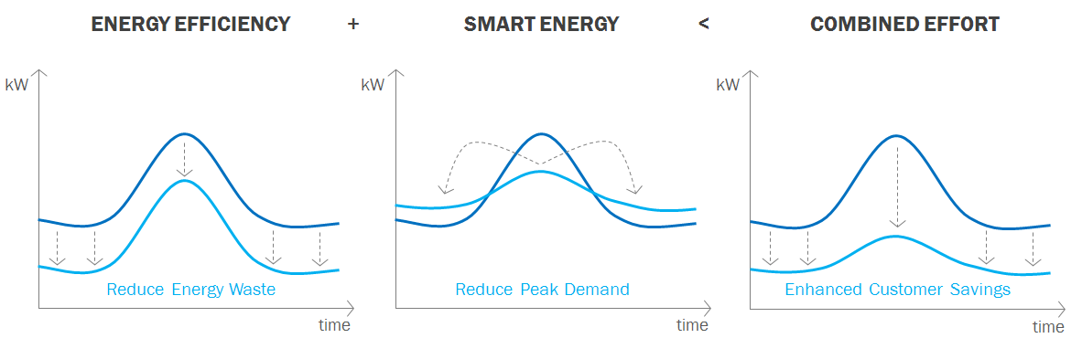

Understanding the Synergies
Consumers Energy is engaged in various pilot programs to better understand the synergies that exist between its Energy Efficiency and Smart Energy initiatives. Currently, the Company offers customers three energy efficiency pilots that leverage the enhanced metering capabilities of the Company’s Smart Energy investments. These include the Smart (Learning) Thermostats, Behavior Demand Response (“BDR”), and Smart Energy Challenge pilots. Beginning in 2017, the Company will also offer its customers DPP and Prepay tariff options that will leverage the enhanced communication functions of the Company’s Web Portal and smart metering technology. These pilots and future tariff options promote reducing energy consumption through timely feedback, proactive communication, and enhanced customer insights into the cost of their electric use. Below is a vignette of the combined efforts.

Energy Optimization & Smart Energy Pilots

Smart (Learning) Thermostats Pilot
The intent of the Smart Thermostat pilot was to better understand the effect of enabling technology and timely feedback on customer energy use behavior. Participants in this pilot received one of three types of WiFi enabled smart thermostats. The three thermostats evaluated in the pilot were selected based on their features, functions, and varying ease of use. The Company provided a complete “turn-key” customer experience by installing 272 thermostats equally across Jackson, Lansing, and Kalamazoo.
Consumers Energy tested both a contractor-installed and self-installation model for customer satisfaction as well as whether customers demonstrated sustained interaction with the technology. Going forward, energy savings will be evaluated based on winter and summer use from 2014 to 2015 including one season of gas use and two seasons of summer use. If sustained energy savings behavior is demonstrated, this technology will assist our customers with energy savings and deeper understanding of energy use. Initial pilot findings indicate 93% of customers programmed a schedule into their smart thermostat and experienced high satisfaction with the program. Evaluation continues to determine where the high satisfaction comes from. A complete turn-key installation provides a satisfying experience for most customers regardless of the technology being tested.
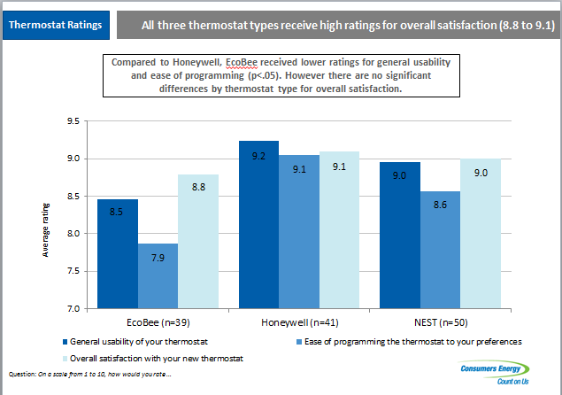

BDR Pilot
The intent of BDR pilot was to better understand the effect of providing proactive, timely, and frequent communications on customer energy use behavior absent a standard price signal mechanism. Consumers Energy collaborated with two other North American utilities in a Smart Meter enabled pilot program. During the summers of 2014 and 2015, customers were encouraged to use less energy on the three hottest days. These peak energy day communications were intended to reduce consumption through voluntary customer activities. This pilot provided outbound communications before, during, and after the target peak energy days and access to resources for customers to learn more about energy efficiency. A total of 70,000 customers participated in the pilot.

Smart Energy Challenge Pilot
The intent of the Smart Energy Challenge pilot was to better understand the effect of a community-focused initiative designed to promote energy efficiency and the benefits of smart metering technologies. More than 2,500 customers participated and were engaged through a unique event website, local events, and organizations. As an incentive to participate, customers could earn “catalog coins” by performing various energy saving activities. Energy credits were redeemable for gift cards, energy efficiency products, or could be donated to a nonprofit organization.
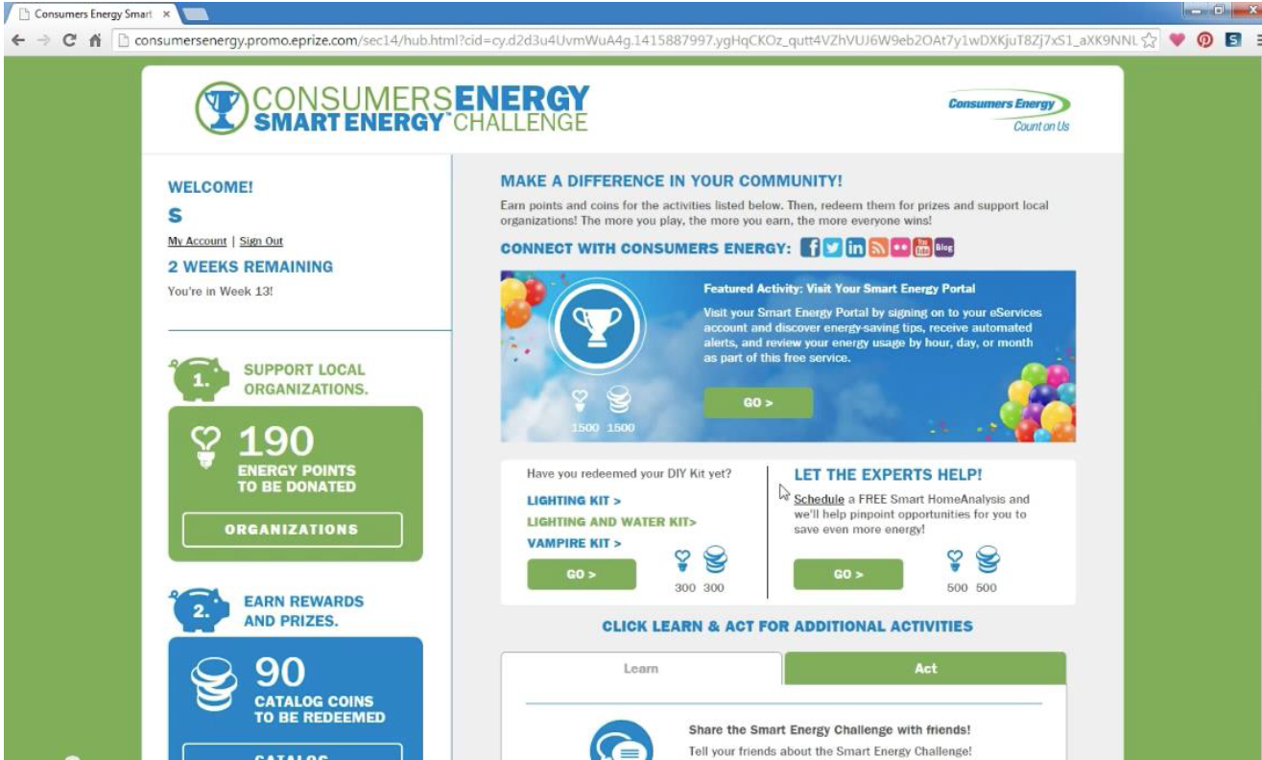
The Company found that 85% of those who participated in the program logged into the Consumers Energy Smart Energy Portal more than once to track changes in their energy use.
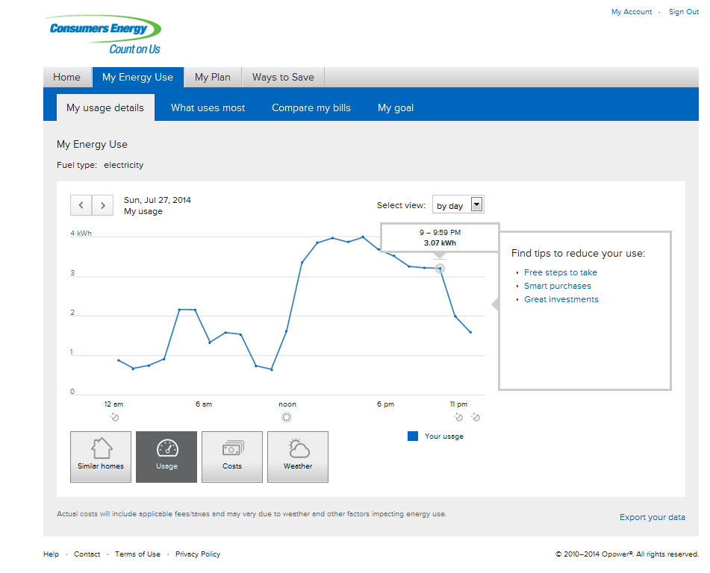
And they became more aware of other ways to reduce energy waste.
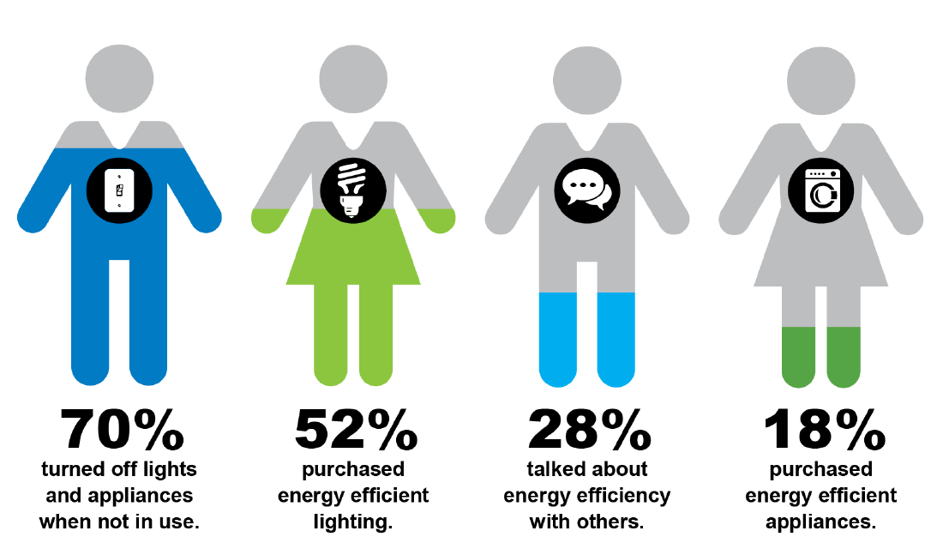
The popularity and positive customer feedback from the 2014 pilot encouraged us to follow-up with a 2015 Smart Energy Challenge Pilot in Kalamazoo.

Additional Energy Saving Options

PrePay
The PrePay program will allow customers to purchase energy ahead of consumption. Customers will be provided access to their energy use through the smart grid network to provide near real-time information on total consumption, rate of consumption, and predictive tools as their balance decreases. By purchasing electricity in advance, customers will change their use behavior to potentially receive a financial benefit in the form of lower total energy consumption and bill.
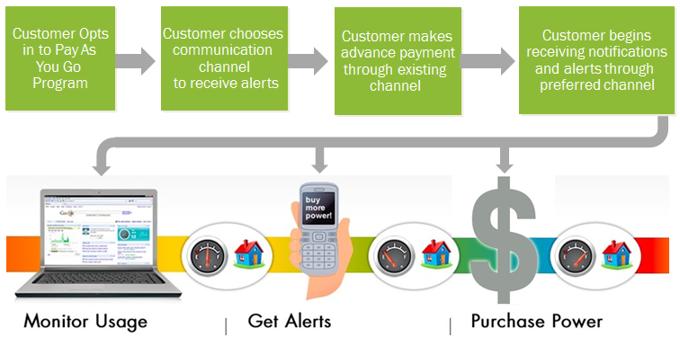
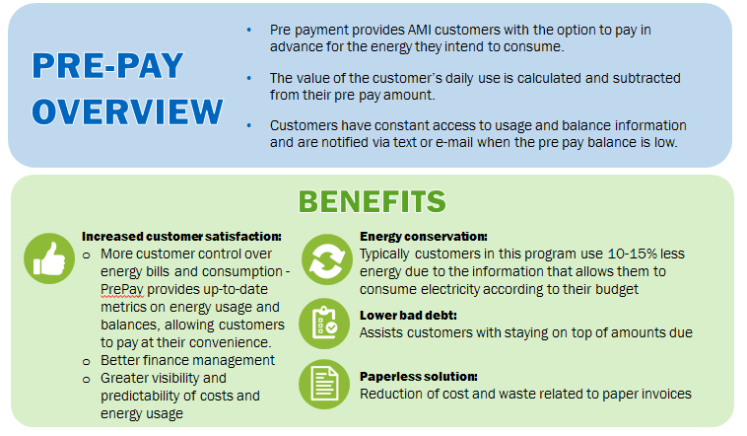

 | Conclusion
Consumers Energy is committed to its customers and offers programs and pricing options to optimize customer savings. The Company is well positioned to offer customers TOU rates and other pricing options thanks in large part to an AMI infrastructure investment, Smart Energy. To that end, the Company is leveraging newly installed AMI technology that connects the customer’s consumption data with energy efficiency opportunities and rate choices. We believe these additional pricing options will raise customer satisfaction and help meet future energy needs.
Plans to market these new pricing options to customers have been developed and will continue to be refined as the Company learns and adapts to customer response. Metrics are being put in place to help gauge and monitor the success of these new offerings.
The programs discussed in this report offer the opportunity for the Company to meet future energy and capacity requirements in a way where customers can engage with their utility on a deeper level thereby reducing energy costs for all customers.

Appendix A – Dynamic Peak Pricing Marketing Tactics
The installation vendor will deploy the following marketing tactics to recruit participants for the program.
 | 2017 | 2018
Micro Website | A program micro website will provide Consumers Energy customers with the ability to confirm eligibility, review program benefits, link to the consumersenergy.com/smartenergy portal for rate comparisons, and enroll in the program. During the enrollment process, customers will select a rate plan, agree to terms and conditions and provide their preferred contact methods for event notifications. The site will be seamlessly linked to Consumers Energy web site and be consistent with Consumers Energy web format and site navigation. | The micro website will be updated as appropriate.
Direct Mail | Direct mail piece will be a personalized letter in a business-sized envelope with the Consumers Energy brand directing the customer to the self-serve micro site to enroll in the program or call the call center for personalized support to help evaluate the rate options.  The implementation vendor will manage the entire direct mail process - from preparing the mail pieces, to releasing the mail batches. | Direct mail piece will be a personalized letter in a business-sized envelope with the Consumers Energy brand directing the customer to the self-serve micro site to enroll in the program or call the call center for personalized support to help evaluate the rate options.  Mailers will be distributed in 12 monthly drops. The implementation vendor will manage the entire direct mail process - from preparing the mail pieces, to releasing the mail batches. Volume of mail may be adjusted as needed based on actual response rates.
Bill Inserts | An initial bill insert to recruit participants for the program using Consumers Energy branding, followed by seasonal updates to bill insert design. Consumers Energy will distribute bill insert to intended targets. | An initial bill insert to recruit participants for the program using Consumers Energy branding, followed by seasonal updates to bill insert design. Consumers Energy will distribute bill insert to intended targets.
E-mail Campaign | E-mail designed to promote the program using Consumers Energy branding, with seasonal updates to email design. Consumers Energy will distribute email to intended targets. | E-mail designed to promote the program using Consumers Energy branding, with seasonal updates to email design. Consumers Energy will distribute email to intended targets.

As reported in the Company’s 2014 MPSC annual report, there were 1,820 residential TOU customers, an additional 669 on experimental residential plug-in vehicle rates, 1,099 commercial GPD rate customers, 40 commercial general primary TOU pilot rate customers, 654 industrial GPD rate customers, 14 industrial general service metal melting pilot customers, and 28 industrial GPTU pilot customers.
Consumers Energy records electric interval data on hourly intervals for billing purposes and customer use presentment. Demand rates also record use at 15 minute intervals for demand billing and On-Peak demand charges.
During the summer of 2014, 68% of residential consumption billed was priced at the First 600 kWh rate and 32% of residential consumption billed was priced at the Over 600 kWh rate. (Source: L. Warriner 10/20/15 general ledger analysis of account 4001120 and account 4001121)
Off-Peak time periods represent 128 hours during a 168 hour calendar week.
On-Peak time periods represent 40 hours during a 168 hour calendar week.
Designated Company holidays are: New Year's Day - January 1; Memorial Day – Last Monday in May; Independence Day - July 4; Labor Day - First Monday in September; Thanksgiving Day - Fourth Thursday in November; and Christmas Day - December 25. Whenever January 1, July 4, or December 25 fall on Sunday, extended holiday periods such as Monday, January 2, Monday, July 5 and Monday, December 26 shall not be considered as holidays for application of Off-Peak hours.
The Economic Trigger Price is the greater of the average Real-Time Locational Marginal Price (“RT LMP”) at Consumers Energy’s load node CONS.CETR during the previous summer during hours 3-5 p.m., OR 150% of the High-Peak Energy Charge listed in the rate sheet. In the event of a MISO declared capacity emergency, Consumers Energy notifies customers via ARCOS or other near-instantaneous notification system. Each of these customers has an assigned Consumers Energy account manager who reviews performance with them.
A system integrity event is an event in which MISO has declared an electric capacity emergency in the Michigan Electric Transmissin Company (“METC”) balancing area, during which MISO requires market participants to shed load in order to bring the grid back to stability. Customers are notified via ARCOS or other near-instantaneous notification system. Consumers Energy has not had a system integrity event in a number of years.
Case No. U-16794, witness STHirsch, Exhibit A-18 (STH-1), June 2011.
Case No. U-16794, witness STHirsch, Exhibit A-19 (STH-2), June 2011.
Load reductions were measured at the customer’s meter, the actual generation capacity impact would also need to factor in energy losses that would typically occur during a summer peak time.
The bill credit for residential direct load administration participants during 2015 was -$0.025099 per kWh for all use in excess of 600 kWh/bill month.
PLMA Spring Conference, Residential Customer Engagement Panel, Presentation by David Ladd of Cadmus. Sanyou Relay Spec Sheet provided by Eaton Corporation.
Source: The Brattle Group: http://www.brattle.com/system/publications/pdfs/000/004/465/original/Direct_Load_Control_of_Residential_Air_Conditioners_in_Texas_Faruqui_PUCT_Oct_25_2012.pdf?1378772107
The Company may call up to eight Critical Peak Events in the summer months of June through September, excluding weekends and holidays, for the On-Peak hours of 2 p.m. to 6 p.m. During a Critical Peak Event, customers will be charged the CPP in the place of the On-Peak power supply charge.
Case No. U-16794, witness STHirsch, Exhibit A-21 (STH-4), June 2011.
Post-Install survey.

